**Skupina A 31.8.2013 r. 2004**

|  |  |  |  |  |  |  |
| --- | --- | --- | --- | --- | --- | --- |
|  | **Přihlášené týmy** | |  |  |  |  |
| 1 | Vlašim |  |  |  |  |  |
| 2 | Braník B |  |  |  |  |  |
| 3 | Bohemians |  |  |  |  |  |
| 4 | Rokycany |  |  |  |  |  |
| 5 | Sparta |  |  |  |  |  |
|  |  |  |  |  |  |  |
|  |  |  |  |  |  |  |
|  |  |  |  |  |  |  |
|  |  |  |  | D |  | H |
| 9:00 | Braník B | Sparta | : |  | **:** |  |
| 9:20 | Bohemians | Rokycany | : |  | **:** |  |
| 9:40 | Vlašim | Braník B | : |  | **:** |  |
| 10:00 | Sparta | Bohemians | : |  | **:** |  |
| 10:20 | Vlašim | Rokycany | : |  | **:** |  |
| 10:40 | Braník B | Bohemians | : |  | **:** |  |
| 11:00 | Rokycany | Sparta | : |  | **:** |  |
| 11:20 | Vlašim | Bohemians | : |  | **:** |  |
| 11:40 | Braník B | Rokycany | : |  | **:** |  |
| 12:00 | Sparta | Vlašim | : |  | **:** |  |
| 12:20 | A1 | B2 | : |  | **:** |  |
| 12:40 | 0 9.místo |  | : |  | **:** |  |
| 13:00 | o 5.místo |  | : |  | **:** |  |
| 13:20 | Finále |  | : |  | **:** |  |

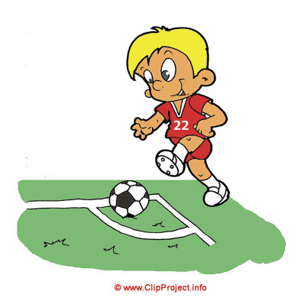

Skupina B

|  |  |  |  |  |  |  |
| --- | --- | --- | --- | --- | --- | --- |
|  | **Přihlášené týmy** | |  |  |  |  |
| 1 | Kr.Dvůr |  |  |  |  |  |
| 2 | Braník A |  |  |  |  |  |
| 3 | Sokol Stráž |  |  |  |  |  |
| 4 | Sparta B |  |  |  |  |  |
| 5 | Sokol Řepy |  |  |  |  |  |
|  |  |  |  |  |  |  |
|  |  |  |  |  |  |  |
|  |  |  |  |  |  |  |
|  |  |  |  | D |  | H |
| 9:00 | Braník A | Sokol Řepy | : |  | **:** |  |
| 9:20 | Sokol Stráž | Sparta B | : |  | **:** |  |
| 9:40 | Kr.Dvůr | Braník A | : |  | **:** |  |
| 10:00 | Sokol Řepy | Sokol Stráž | : |  | **:** |  |
| 10:20 | Kr.Dvůr | Sparta B | : |  | **:** |  |
| 10:40 | Braník A | Sokol Stráž | : |  | **:** |  |
| 11:00 | Sparta B | Sokol Řepy | : |  | **:** |  |
| 11:20 | Kr.Dvůr | Sokol Stráž | : |  | **:** |  |
| 11:40 | Braník A | Sparta B | : |  | **:** |  |
| 12:00 | Sokol Řepy | Kr.Dvůr | : |  | **:** |  |
| 12:20 | A2 | B1 | : |  | **:** |  |
| 12:40 | O 7.místo |  | : |  | **:** |  |
| 13:00 | O 3.místo |  | : |  | **:** |  |
|  |  |  | : |  | **:** |  |

